PC CARES Bulletin

End of Year 2022

Reflecting on the year so far, we are grateful to those who spent time and energy imagining how to increase youth wellness using PC CARES. Whether you served on our Local Steering Committee, received care packages and shared its contents, attended virtual learning circles, trainings, and presentations, or discussed the data behind what we do—THANK YOU!

Training of Facilitators in Bethel
This November was a unique opportunity for students in the Rural Human Services (RHS) program to partner with PC CARES for their certificate practicum project. Students in the RHS program travel from their remote villages to attend residential weeklong intensive training sessions each month for two academic years, then complete a practicum as a culmination of the experience. This fall, the University of Alaska Fairbanks Kuskokwim Campus students gathered in Bethel for a Training of Facilitators, and will host 5 learning circles in their communities as their practicum project.
Embedding PC CARES training within an existing certificate program offers facilitation support centrally and regularly to learning circle facilitators, along with the customs and practices honed by the RHS program to support students and create a more inclusive, decolonized learning environment. RHS intensives often involve time for self-care and community care when tackling difficult subjects like suicide prevention and involve Alaska Native Elders in teaching spaces. “We were blessed with two Elders, Evelyn Day and Lucy Andrews, who supported us in our learning and shared how grateful they were for the students being strong enough to take this training and bring it back to their communities.” Said course instructor and RHS program head, Diane McEachern.
The training also welcomed a few returning facilitators looking for a “refresher” on the learning circles, plus a few additional new facilitators for the communities of Nome and Kotzebue who are putting their learning into their practice.
“What I enjoyed about this training was how the participants were so committed to bringing helpful change to their communities,” said Diane McEachern. “Our days were packed and the enthusiasm was wonderful. And we had fun with some great laughs as a community of learners for the week.”
RHS students who have been trained as PC CARES facilitators will discuss progress, challenges, and community successes to hosting learning circles during their subsequent monthly certificate training sessions.
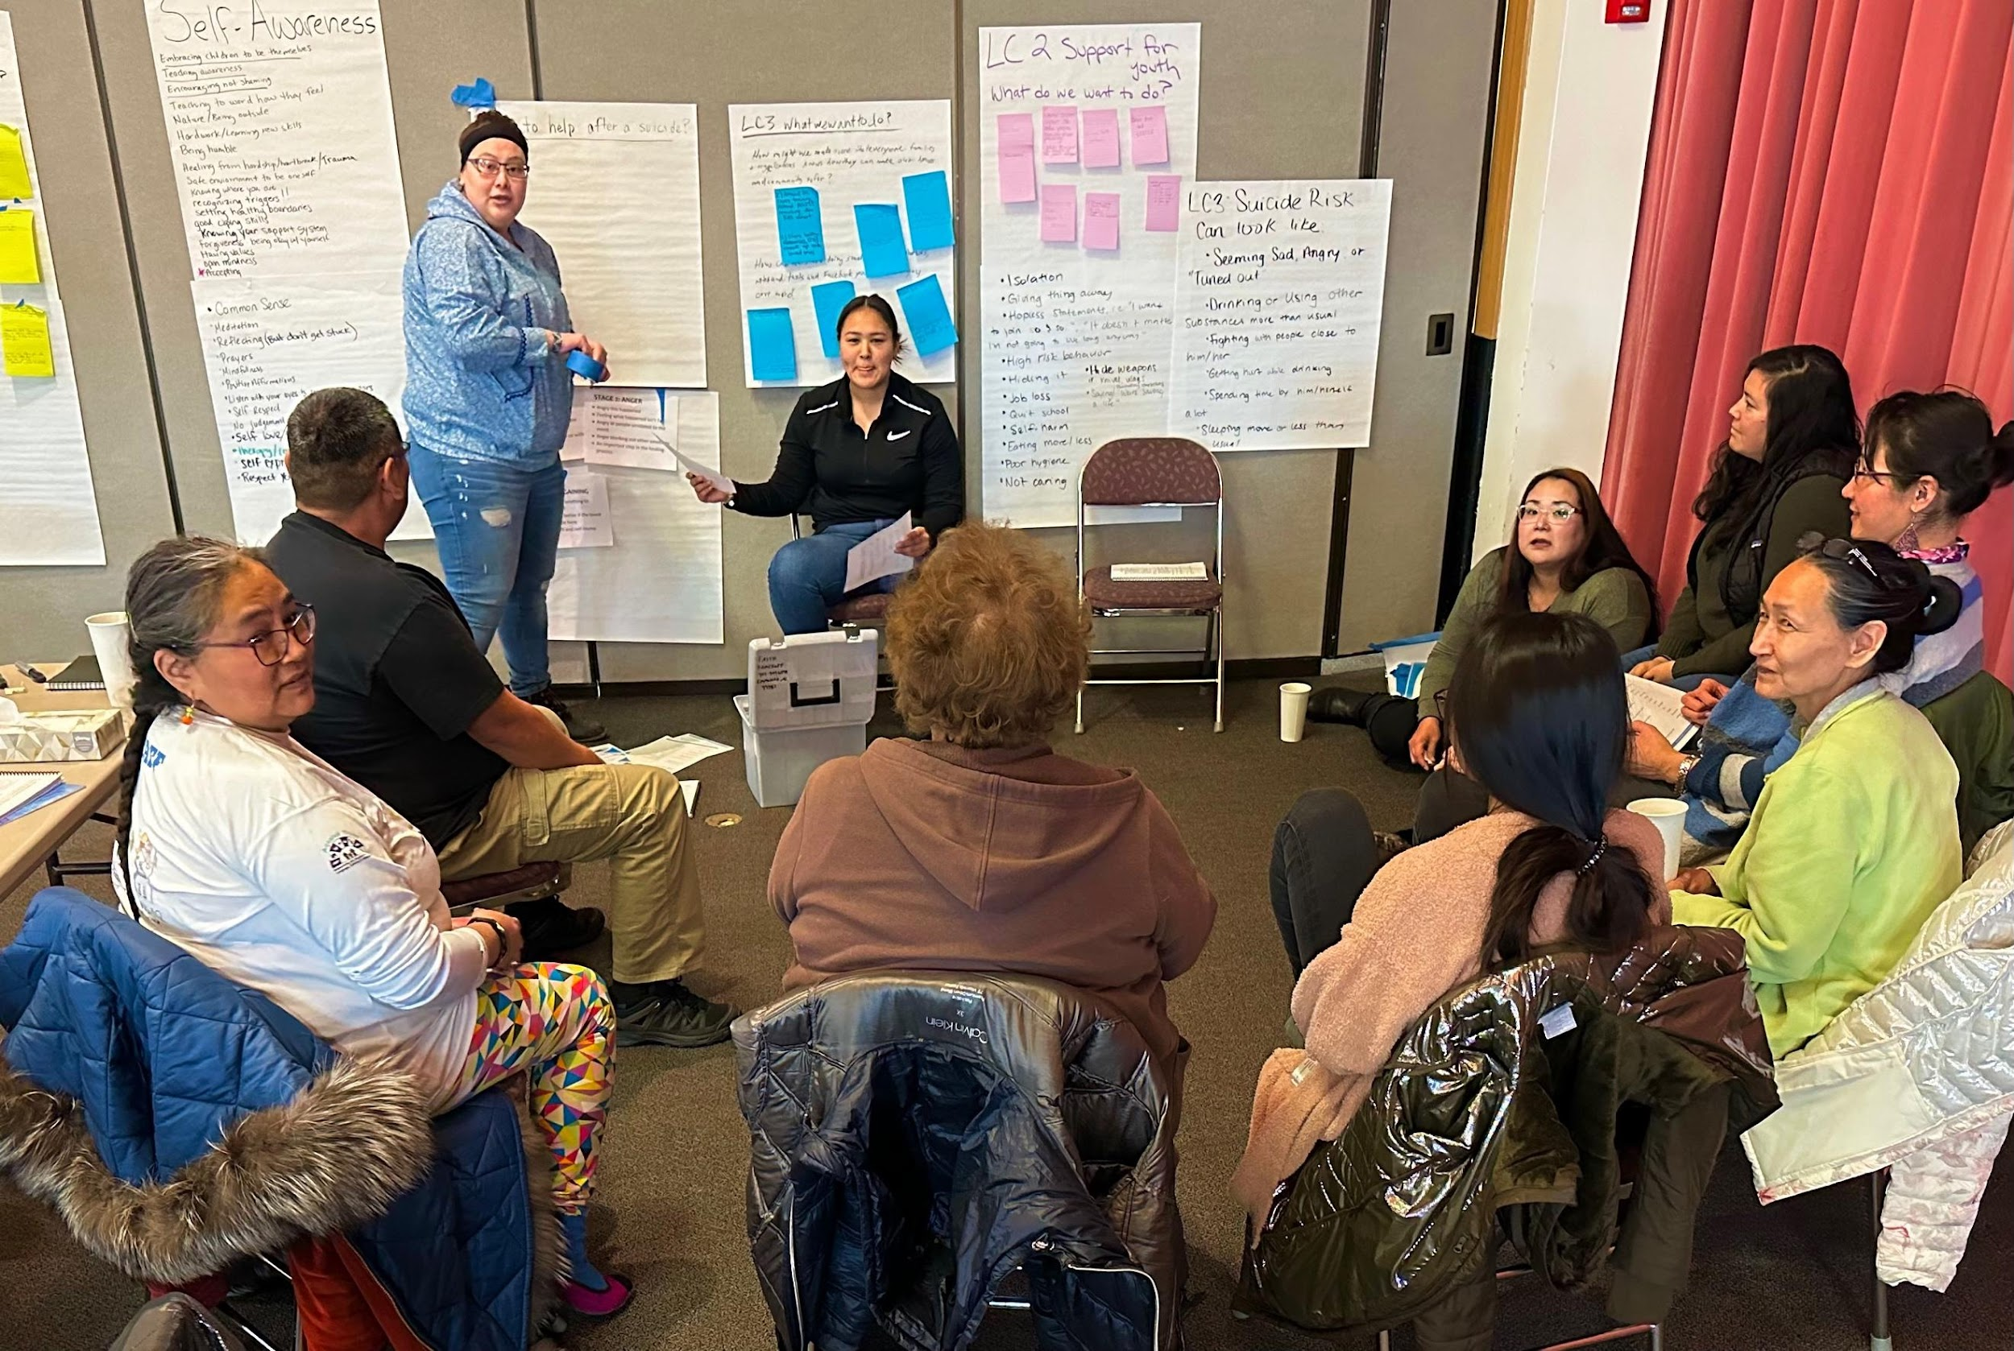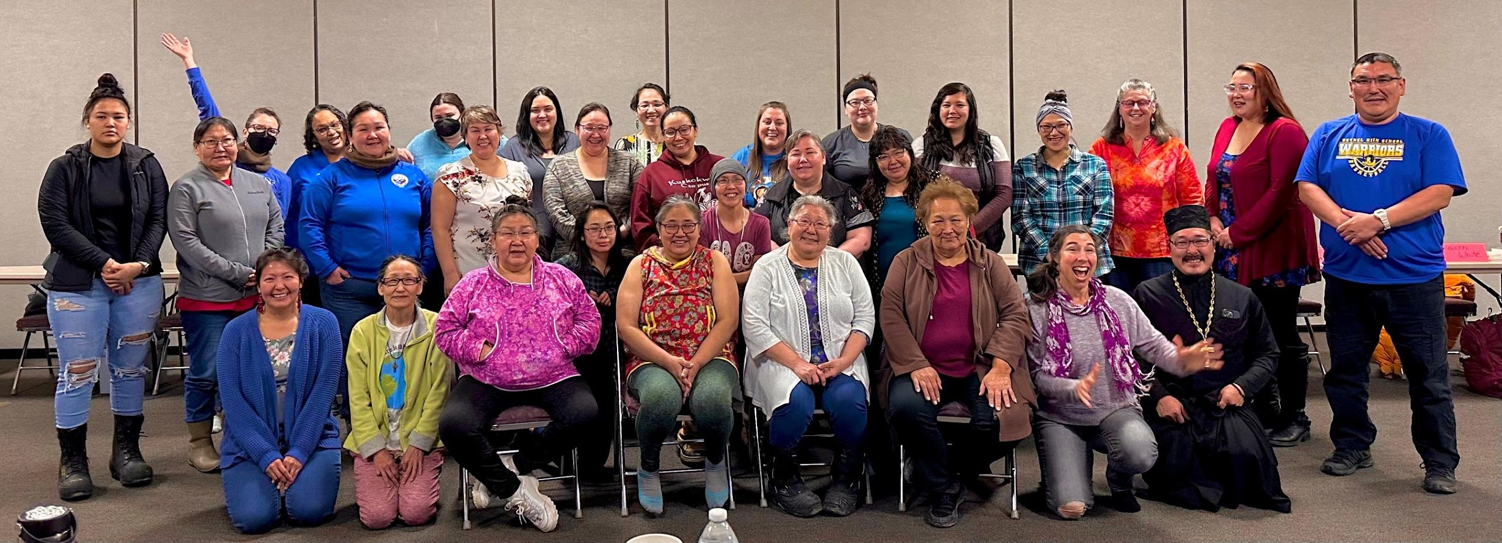

In-person learning circles hosted across Alaska
- In December and January, the village of Teller hosted their first in-person, post-pandemic learning circles. Eight people attended and said they were looking forward to attending the next LC, scheduled for late January.
- Kotzebue has hosted 3 LCs in person so far this winter!
- Tuluksak and Mountain Village hosted LC1
- More learning circles are scheduled in Kwethluk and Emmonak

PC CARES learning circles approved for health aide CMEs
Health aides are often key participants to PC CARES learning circles, since they are often the primary health care provider in the village, responding and treating a wide variety of health concerns. PC CARES was once again approved by the Alaska Native Tribal Health Consortium for Continuing Medical Education (CME) hours, so that health aides in participating villages can earn up to 12 credit hours for their participation in PC CARES learning circles. This provides supervisors with the incentive to allow learning circle participation during work hours, or to allow attendance to count for paid time.

On December 15th, the village of Teller hosted their first in-person, post-pandemic learning circle. Eight people attended and said they were looking forward to attending the next LC, scheduled for early January.

Hoping to start up in-person more learning circles in Bering Strait and Northwest Arctic communities. If you were trained as a facilitator in 2015 and 2019, or are interested in supporting learning circles in your community, please contact Tara at pc-cares.org.

Virtual PC CARES shows efficacy and feasibility
Amongst COVID isolation and social distancing guidelines, PC CARES trainers hosted learning circles with mostly non-Native school staff and a few tribal health care providers. To learn more about our switch from in-person to online delivery, or what a learning circle is like, please visit: https://www.pc-cares.org/virtual-learning-circles
For Virtual PC CARES, we measured feasibility and efficacy with the model adapted for online delivery with baseline and follow-up surveys. Combining both years of the virtual series, we gathered 713 Baseline surveys, 401 Follow Up surveys, with 382 matched pairs (same respondent taking both surveys). PC CARES demonstrated. Over two years, participant surveys showed high levels of satisfaction across all sessions (>90%), with consistent attendance over 5 months in both school years.
Virtual learning circle attendance
 | 2020-21 | 2021-22 | Total
LC1 | 83 | 70 | 153
LC2 | 77 | 63 | 140
LC3 | 68 | 41 | 109
LC4 | 68 | 55 | 123
LC5 | 56 | 54 | 110
LC6 | 65 | 41 | 106
LC7 | 63 | 34 | 97
Using a multilevel growth model testing for change in participant outcomes, PC CARES increased participants’ suicide prevention knowledge, self-efficacy, and Communities of Practice (CoP) over 7 measurement timepoints spanning from baseline to 1 month post completion of the LCs. Preliminary social network analyses also found increases in participants’ prevention-oriented behaviors, indicating increases in 12 of the 18 measured network behaviors between the pre- and post-assessments. Areas with the largest increases were: connecting youth to help; listening to youth about their experiences; helping youth talk about grief; working with other adults to prevent suicide and prevent further harm after a suicide occurs. Adults also reported more students seeking help from them.
Wrapping up PC CARES care packages: What did people think?
1. In March 2020, the pandemic stopped our original plan to gather people in-person for learning circles. That summer, we started sending packages to the people who had attended a learning circle in their village to stay in touch and remind people about their learning and conversations at PC CARES learning circles. After initial positive reactions to the care packages, we decided to keep sending them regularly to anyone who signed up to receive them.
Ten care packages were sent with items and messages curated by members of the Local Steering Committee, research staff, and coinciding with a tidbit from learning circles—“What does the research show?” The current mailing list consisted of supportive adults with experience or exposure to the PC CARES project in the Northwest Arctic (~40%), Bering Strait (~55%), and Yukon-Kuskokwim Delta (~5%) regions.

Care Package Name | Sent | Research-Based Message | Number of Recipients
Small Acts of Kindness (SAOK)  1 | June 2020 | A small act of kindness, which doesn’t require anything in return, can show others you care about them and encourage them to seek help if they need it | 140
Talk with Youth  2 | August 2020 | Youths want adults talk to them more, and believe this could effectively prevent youth suicide in their village | 140
Listening Well  3 | March 2021 | The trigger-emotion-response model can guide us better understand young people’s emotions. By listening without judgment, adults can improve connections with youth | 170
Nominated Small Acts of Kindness  4 | March 2021 | A small act of kindness, which doesn’t require anything in return, can show others you care about them | 192
Restful Sleep  5 | May 2021 | Restful sleep has benefits to physical and psychological health. Spreading this information to young people will lead them to making better decisions and improved mental health | 74
Healthy Living  6 | August 2021 | Inviting young people to engage more outdoor and physical activities can improve their physical and mental health | 75
Reach out to Youth to Show You Care  7 | October 2021 | When we let young people know we are always there for them, and always willing to listen to them, they are more likely to seek help when they need it | 170
Safe Homes  8 | January 2022 | Securing dangerous items (firearms, ammo, medications, alcohol) can make our home safer, and can prevent harm from impulsive decisions—even just 10 minutes can save a life. | 201
Building Connections  9 | May 2022 | Connections with youth can be built through small conversations, outdoor activities, and understanding family history and cultural background | 205
Finding Balance  10 | July 2022 | Four areas wellness (physical, mental, spiritual, and emotional) intertwined, and enhancing our health in one area usually has benefits in others | 200

2.
Most recipients were happy to receive the packages and willing to utilize them in the ways suggested in the package. There were some notable differences in responses to the care packages:
- In Care Package #6 (Healthy Living), one of the responses showed a level of 78% agreeing in the question of “getting enough exercise can prevent suicide”, perhaps because the suggested action was too tangential to a big issue like suicide prevention. Recipients had different opinions on this specific question.
- 3. In Care Packages 4, 8 and 9, agreement with satisfaction and understanding of the care package/PC CARES messaging was lower than other packages. We theorize that for Care Package #4 (the second Small Acts of Kindness mailing sent to a new list of nominated school staff and service providers), the lower ratings might because recipients were less familiar with PC CARES.
- For Care Package #8 (Safe Homes), the contents were more directly related to suicide prevention, so the responses were more diverse.
- For Care Package #9 (Building Connections), the activities recipients were encouraged to try varied and recipients might have trouble following the guides.
4. In surveys and interviews with care package recipients, certain items were the mentioned often as being most useful, favored, or noteworthy. Here were the most popular items:

Berry-picking buckets with handle and lid – Included in Talk with Youth and Finding Healthy Balance packages; 7 mentions in interviews and surveys  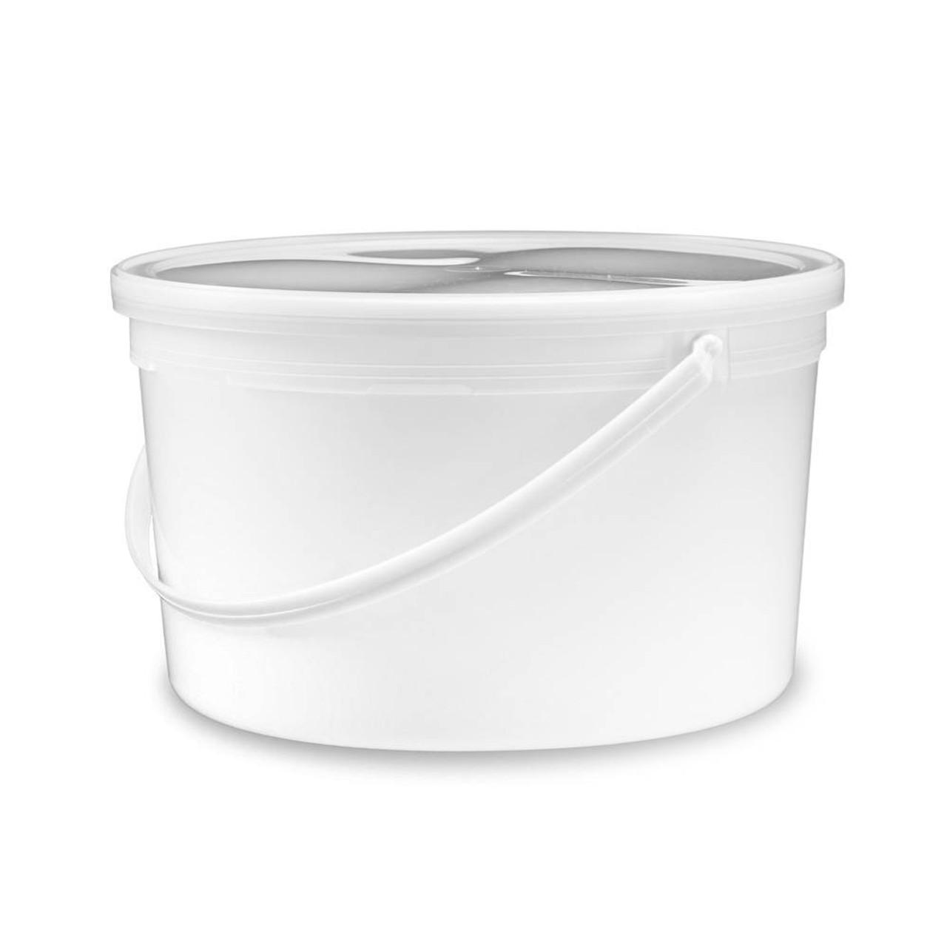 | “Dear self” prompt cards – Included in Building Connection package; 4 mentions  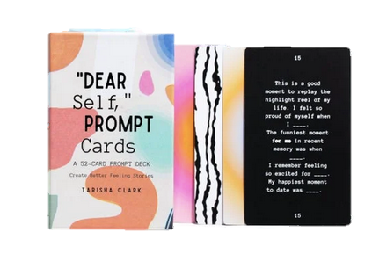
“You Matter” Pop-Open Cards – Included in Small Acts of Kindness and Reach Out to Youth packages; mentioned 3 times in surveys and interviews  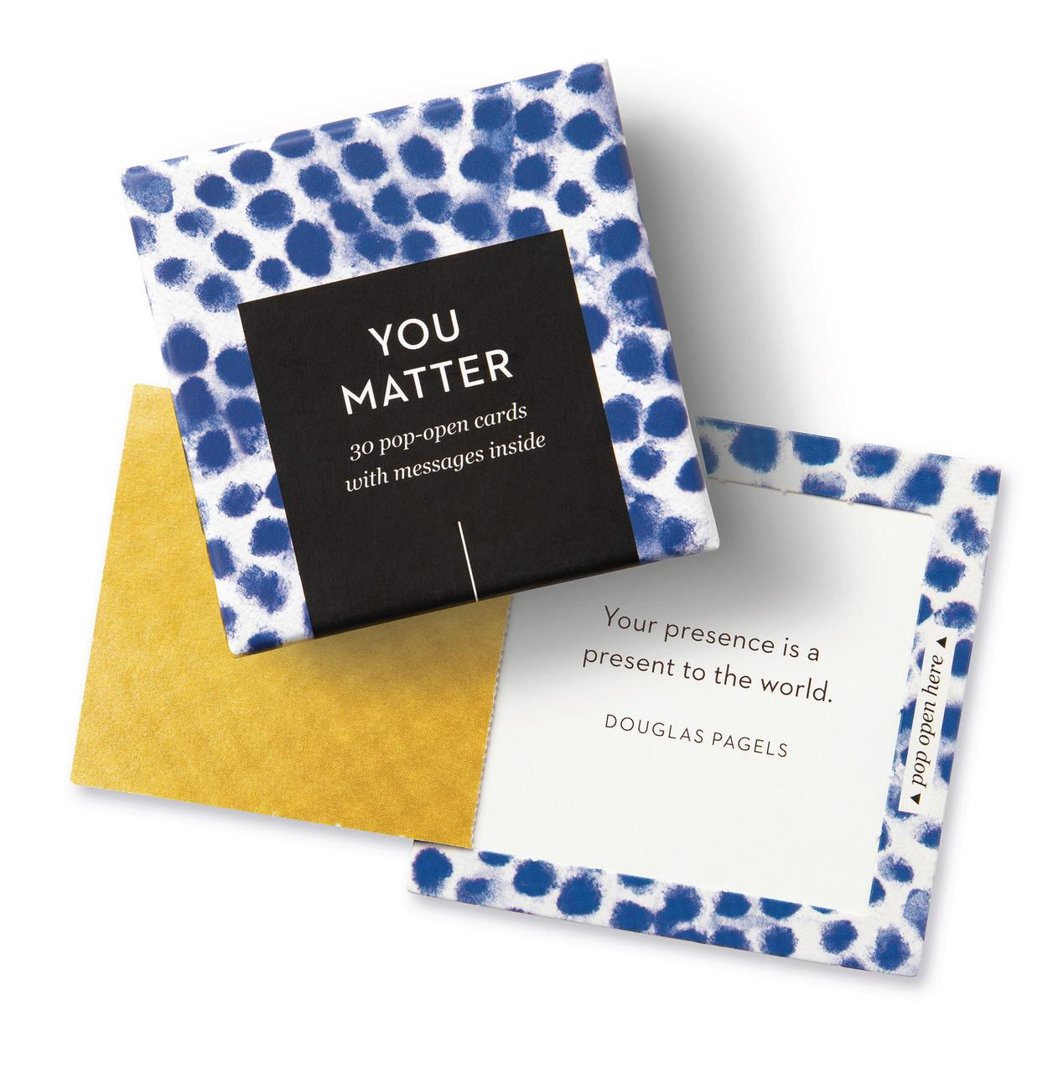 | Custom magnet with self-care wheel – Included in the Listening Well care package; mentioned 3 times in interviews and surveys  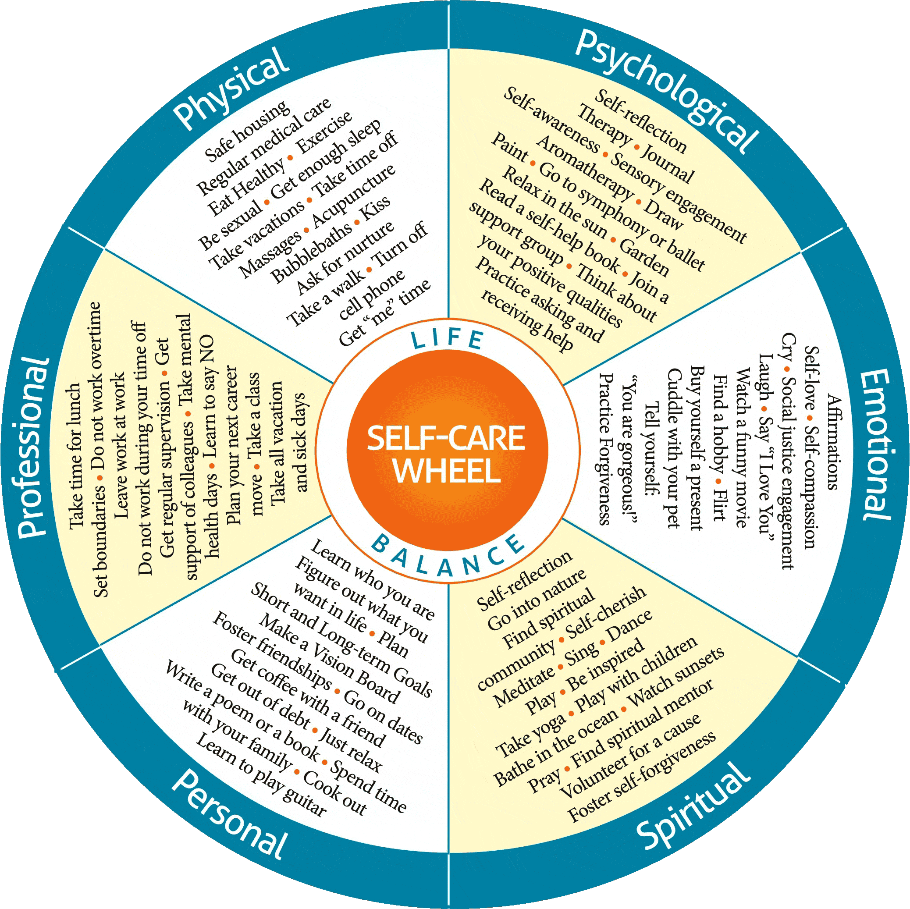
Locking medication pouch (9x6”) – Included in Safe Homes package; 3 mentions*  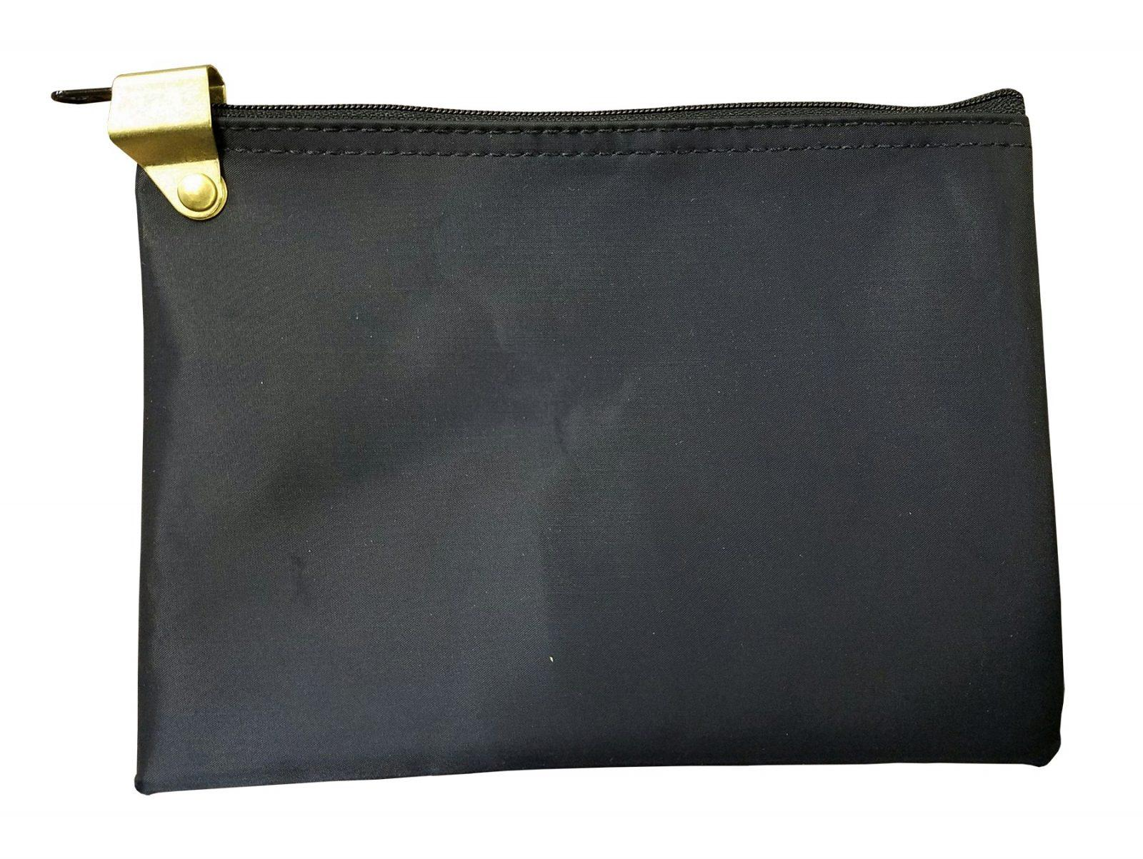  *Note: need to include instructions for how to set the lock combination in the package | Decaf coffee from Native-owned business (currently sold out) – Included in the Restful Sleep care package; 3 mentions  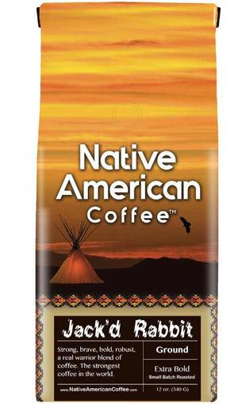

5. While our response rate for surveys was relatively low, (we received 220 surveys for all care packages for a response rate of 17%), we received very positive ratings from care package recipients. Overall, they expressed that they 1) liked getting the care packages, 2) found the information in the care packages helpful, and 3) offered actions they could take.
Care package surveys included some questions repeated verbatim for every package (like “I am happy the PC CARES team sent this package to me”) while other survey questions were specific to the theme or contents of the Care Package, but shared the similar phrasing across surveys.
Actions taken by participants after receiving the packages had more variance compared with recipients’ responses to the satisfaction and comprehension questions in the care package surveys.
Looking at actions or intended actions after receiving a care package, we saw relatively higher participation rates in reading the letters and information cards and slightly lower rates of spending time on activities with youths and using small goodies with family members/youths. The response rates of joining PC CARES At Home Facebook group remained relatively low – in fact, more than one interviewee reported he/she does not use Facebook that often and suggested using Instagram or other popular social media platforms.

For descriptions of past packages, visit:
https://www.pc-cares.org/cp-timeline
For a slideshow of packages we’ve sent:
https://www.pc-cares.org/cp-gallery

Recent PC CARES presentations

The Forum on Mental Health and Substance Use Disorders and the Forum for Children’s Well-Being at the National Academies of Sciences, Engineering, and Medicine convened a three-part virtual public workshop on April 22, 2022, May 13, 2022, and June 10, 2022, to examine suicide risk and protective factors in Indigenous populations, discuss culturally appropriate and effective suicide prevention policies and programs, explore existing data systems and how data can be used for tracking suicide rates, and consider opportunities for action. On behalf of the Promoting Community Conversations about Research to End Suicide (PC CARES) project, Lauren White (University of Michigan, citizen of Choctaw Nation) delivered the following talk.

As always, thanks for reading, and thank you for being involved with PC CARES!

